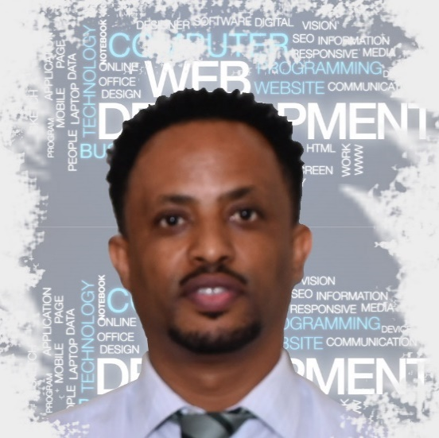

Wondwossen
Yalew
Fu ll S t a c k W e b D e v e l o p e r

CONTACT ME FULL STACK DEVELOPMENT ( MERN ).

Alexandria, Virginia

wondwossen32@gmail.com
www.thwondie.com @wondwossen-yalew

TECHNICAL PROFILE (SKILLS)

JavaScript HTML CSS
React Rest API Node Express JSON
Bootstrap MySQL
jQuery GitHub
MS Excel
Adobe Photoshop
VS Code

Motivated and dynamic Web Developer with a keen focus and experience in web application development and web layout design, with a strong work ethic and innate ability to adapt to ever-changing and challenging environments. Education and experience in comprehensive problem-solving, creative troubleshooting, and complex project management. Accomplished with effective collaboration skills, team-building capabilities, and leadership in diverse and multifaceted operations.

PERSONAL PROJECTS

Built Amazon-clone app using react, an e-commerce store with full functionality, front, and back end.
Built Netflix-clone using react which is an online video streaming service.
Recreated Apple’s website using React - created React components for various pages and sections
- Integrated Apple’s YouTube channel with the website using REST API.
Experience with Adobe Photoshop designs over the last 10 years.


MY portfolio website

